PROBLEM SOLVING AND TESTING USING JAVA
WEEK 1 – TASKS

NAME : A.LAKSHMI NARSIMHA REDDY
VTU NO : VTU25493

TASK 1: Iseven

AIM : To write a Java program that checks whether a given integer is even or odd.
ALGORITHM :
1.Start.
2. Take an integer input (input1).
3. Compute input 1 % 2.
4. If remainder = 0 → number is even → return 2.
5. Else → number is odd → return 1.
6. End.
PROGRAM :

class IsEven {
public static void main(String[] args) {
int num = 10;
if (num % 2 == 0) {
System.out.println(num + " is Even");
} else {
System.out.println(num + " is Odd");}}
}
OUTPUT :
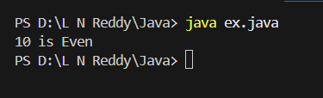

RESULT : Thus, To write a Java program that checks whether a given integer is even or odd is are successfully executed.
TASK 2 : Access and print the element at a given index in an array.

AIM : To write a Java program that takes an array and an index as input, then prints the element present at that index.
ALGORITHM :
1. Start.
2. Read the size of the array.
3. Read the array elements.
4. Read the index to be accessed.
5. Check if the index is valid (0 <= index < array.length).
6. If valid → print the element at that index.
7. Else → print an error message.
8. End.
PROGRAM :

import java.util.*;
public class ex{
public static void main(String[]args){
int arr[] = {20,30,50,10,80};
Scanner sc = new Scanner(System.in);
System.out.println("enter the index :");
int index = sc.nextInt();
if(index>=0 && index<=arr.length){
System.out.println("element of the index is:"+arr[index]);
}else{
System.out.println("invalid index:");
}
}
}
OUTPUT :

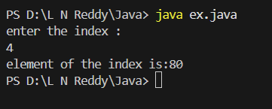

RESULT : Thus, To write a Java program that takes an array and an index as input, then prints the element present at that index is are executed successfully.

TASK 3 : Search for a given element in a sorted array using Binary Search.

AIM : To write a Java program that searches for a given element in a sorted array using the Binary Search algorithm.
ALGORITHM :
1. Start
2. Read the size of the array and its elements (sorted order).
3. Read the element to be searched (key).
4. Initialize low = 0, high = n-1.
5. While low <= high:
6. Compute mid = (low + high) / 2.
7. If arr[mid] == key → return mid.
8. If arr[mid] < key → search in right half (low = mid + 1).
9. Else → search in left half (high = mid - 1).
10.If not found → return -1.
11.End
PROGRAM :

import java.util.*;
public class ex{
public static void main(String[]args){
int arr[] = {10,20,30,40,50} ;
Scanner sc = new Scanner(System.in);
System.out.println("enter a element to search");
int target = sc.nextInt();
int left = 0;
int right = arr.length-1;
while(left<=right){
int mid = (left + right)/2;
if (arr[mid]==target){
System.out.println("the searched element is :"+mid);
return;
}else if(arr[mid]<target){
left = mid + 1;
}else{
right = mid - 1;
} }
System.out.println("not found");
sc.close();
} }
OUTPUT :

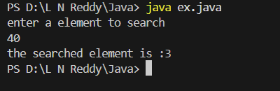

RESULT : Thus, To write a Java program that searches for a given element in a sorted array using the Binary Search algorithm is are executed successfully.

TASK 4 : Find the maximum element in an array of n integers

AIM : To write a Java program that finds and prints the maximum element in an array of n integers.
ALGORITHM :
1. Start.
2. Read the size of the array (n).
3. Read n integers into the array.
4. Initialize max = arr[0].
5. Traverse the array from index 1 to n-1:
6. If arr[i] > max → update max = arr[i].
7. Print max.
8. End.
PROGRAM :

import java.util.*;
public class ex{
public static void main(String[]args){
int arr[] = {1000,220,30,40,50};
int max = arr[0];
for (int i = 1 ; i < arr.length;i++){
if(arr[i]>max){
max = arr[i];}
}
System.out.println("the max element is:"+max);
}
}

OUTPUT :

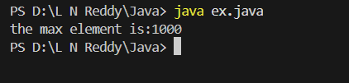

RESULT : Thus, To write a Java program that finds and prints the maximum element in an array of n integers is are executed successfully.

TASK 5 : Given an array of integers and a positive integer K, write a program to find:The Kth smallest element
AIM : To write a Java program that finds the Kth smallest element in an array of integers.
ALGORITHM :
1. Start.
2. Read the size of the array (n).
3. Read n integers into the array.
4. Read the value of K.
5. Sort the array in ascending order.
6. Access the element at index K-1 (since arrays are 0-based).
7. Print that element.
8. End.
PROGRAM :
import java.util.*;
public class ex{
public static void main(String[]args){
int arr[] = {6,8,55,34,3,2};
int k = 1;
Arrays.sort(arr);
System.out.println("the kth smallest term in an array is :"+arr[k-1]); } }

OUTPUT :
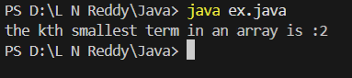

RESULT : Thus, To write a Java program that finds the Kth smallest element in an array of integers is are executed successfully.

TASK 6 : Print all possible pairs of elements from an array of size n.

AIM : To write a Java program that prints all possible pairs of elements from an array of size n.
ALGORITHM :
1. Start.
2. Read the size of the array (n).
3. Read n integers into the array.
4. Use two nested loops:
5. Outer loop runs from i = 0 to n-1.
6. Inner loop runs from j = i+1 to n-1.
7. Print the pair (arr[i], arr[j]).
8. End.
PROGRAM :

public class Arrays {
public static void main(String[] args) {
int nums[] = {2, 4, 6, 8, 10};

for (int i = 0; i < nums.length; i++) {
int curr = nums[i];
for (int j = i + 1; j < nums.length; j++) {
System.out.print("(" + curr + ", " + nums[j] + ") ");
}
System.out.println();
}
}
}

OUTPUT :

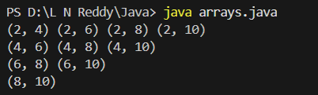

RESULT : Thus,To write a Java program that prints all possible pairs of elements from an array of size n is are successfully executed.
TASK 7 : DigitSum opt: sum of even or odd digits

AIM : To write a Java program that calculates the sum of digits of a given number based on an option:1 or 2.
ALGORITHM :
1. Start.
2. Read an integer number (num).
3. Read the option (opt).
4. If opt = 1 → sum even digits.
5. If opt = 2 → sum odd digits.
6. Extract digits one by one using % 10 and / 10.
7. Check each digit:
8. If digit is even and opt = 1 → add to sum.
9. If digit is odd and opt = 2 → add to sum.
10.Print the sum.
11.End.
PROGRAM :

public class DigitSum {
public static void main(String[] args) {
int num = 123456;
int evenSum = 0, oddSum = 0;
while (num > 0) {
int digit = num % 10;
if (digit % 2 == 0) {
evenSum += digit;
} else {
oddSum += digit;
}
num /= 10;
}
System.out.println("Sum of Even Digits = " + evenSum);
System.out.println("Sum of Odd Digits = " + oddSum);
}
}

OUTPUT :

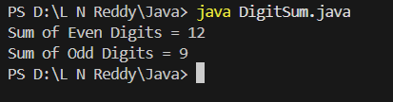

RESULT : Thus,To write a Java program that calculates the sum of digits of a given number based on an option: 1 or 2 is are successfully executed.

TASK 8 : Nth Fibonacci

AIM : To write a Java program that computes the Nth Fibonacci number. Fibonacci sequence: 0, 1, 1, 2, 3, 5, 8, … Formula: F(n) = F(n-1) + F(n-2).
ALGORITHM :
1. Start.
2. Read the integer n.
3. If n == 0 → return 0.
4. If n == 1 → return 1.
5. Otherwise, use iteration:
6. Initialize a = 0, b = 1.
7. Loop from 2 to n:
8. c = a + b
9. Update a = b, b = c.
10.Result = b.
11.Print the result.
12.End.
PROGRAM :

class UserMainCode
{
public int isPalinNum(int input1)
{
int original = input1;
int reverse = 0;
while (input1 > 0) {
int digit = input1 % 10;
reverse = reverse * 10 + digit;
input1 = input1 / 10;
}
if (original == reverse) {
return 2;
} else {
return 1;
}
}
public static void main(String[] args) {
UserMainCode obj = new UserMainCode();
int num = 121;
System.out.println(obj.isPalinNum(num));
}
}

OUTPUT :

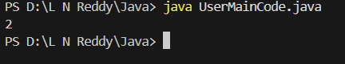

RESULT : Thus, To write a Java program that computes the Nth Fibonacci number is are successfully executed.
TASK 9 : Palindrome Number

AIM : To write a Java program that checks whether a given integer is a palindrome number.
ALGORITHM :
1. Start.
2. Read an integer num.
3. Store the original number in temp.
4. Reverse the digits of num:
5. Initialize rev = 0.
6. While num > 0:
7. Extract digit → digit = num % 10.
8. Update reverse → rev = rev * 10 + digit.
9. Reduce number → num = num / 10.
10.Compare rev with temp.
11.If equal → number is palindrome.
12.Else → not palindrome.
13.End.
PROGRAM :

class UserMainCode
{
public int isPalinNum(int input1)
{
int original = input1;
int reverse = 0;
while (input1 > 0) {
int digit = input1 % 10;
reverse = reverse * 10 + digit;
input1 = input1 / 10;
}
if (original == reverse) {
return 2; // Palindrome
} else {
return 1; // Not Palindrome
}
}
public static void main(String[] args) {
UserMainCode obj = new UserMainCode();
int num = 121; // test value
System.out.println(obj.isPalinNum(num));
}
}
OUTPUT :

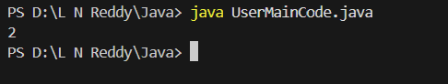

RESULT : Thus,To write a Java program that checks whether a given integer is a palindrome number is are successfully executed.

TASK 10 : Sum of last digit of two given numbers

AIM : To write a Java program that reads two integers and prints the sum of their last digits.
ALGORITHM :
1. Start.
2. Read two integers (num1, num2).
3. Extract the last digit of each number using % 10.
3. last1 = num1 % 10
4. last2 = num2 % 10
5. Compute sum = last1 + last2.
6. Print the result.
7. End.
PROGRAM :
class UserMainCode
{
public int addLastDigits(int input1, int input2)
{
if (input1 < 0) input1 = -input1;
if (input2 < 0) input2 = -input2;
return (input1 % 10) + (input2 % 10);
}
public static void main(String[] args)
{
UserMainCode obj = new UserMainCode();
System.out.println(obj.addLastDigits(123, -78));
}
}
OUTPUT :

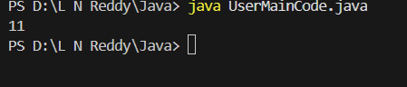

RESULT : Thus,To write a Java program that reads two integers and prints the sum of their last digits is are successfully executed

